Ref: TMT/Amritsar /S0461/2025. 13.9.2025

To,

Amritsar.
Mobile: 9177821954

Dear sir,

Sub :- Supply of 1650 MM Wide And 1.0-4 MM High and Speed Cut-To- Length Machine

We thank you for your enquiry regarding cut to length machine with 1650mm wide and thickness 4.0 mm. We are glad to inform you that we would be in a position to do the required equipment as per the following specifications and descriptions of the machine along with our terms and conditions.

COIL CAR
Maximum weight of coil that can be lifted : 30 MT Max

Maximum thickness of coil that can be holed : 4.0 mm Max

Mode to lift 700 MM : Hydraulic

Drive : Hydraulic motor

MANDREL UNCOILER

Capacity : 35 Ton

Model : Double Arm

Mandrel movement : Hydraulic

Back Tension : Caliper brake, manually adjusted

Coil hold down : Hydraulic

Construction : M. S. Fabricated.

Drive : 7.5 HP along with snubber drive

SHEET LEVELING

PINCHROLL

Number of pinch rollers : 2 Nos

Diameter of the roll : dia 120 mm

Load arrangement for pinch rolls : manual wheel

LEVELER

Type of the machine : 4Hi

Maximum sheet width that can be leveled : 1650 MM

Maximum sheet thickness in MS that can be leveled : 4.0 MM

Minimum sheet thickness in MS that can be leveled : 1.0 MM

Roll dia : 75 mm

No of work rolls : 21 Nos

No of backup rolls : 63 nos

Speed of the machine : 0-60 meters/min

Model : Crossed Beam

Drive : 120 HP – AC motor
The lever is with triangular roll attachment along with hydraulic screw down along with differential load indication. The pinch roll is allowed the strip to move to forward to entry guides.

1650 MM WIDE SHEAR ING UNIT WITH SWILL MECHANISUM

Maximum sheet width that can be sheared : 1650 MM

Maximum sheet thickness in MS that can be sheared : 4 MM

Minimum sheet thickness in MS that can be leveled : 1.0 MM

No of strokes per minuet : 18

Bed width : 550 mm

Power pack : 25 HP

AUTO STACKER

The auto stacker length of 4000 mm length along with auto segregation of material along with two stackers at a time

PRICE

The price of Cut-to-length machine along with power pack and complete package
Rs 1,70,00,000/- (Rupees One crore Seventy Lakhs only)

Motor make : Crompton/ABB/Siemens
Plc : Delta
Rolls material : Hc Hcr d2
Gear box : elecon
Structure : ms fabricated
Shearing blades : HcHcr

GENERAL TERMS & CONDITIONS:

- Price quoted per unit ex-work. Hyderabad.
- Following charges are additional to your account.
- Freight Charge : As actual to be borne by you.
- Sales Tax : Extra gst @ 18%
- Packing charge : As actual to be borne by you.
- Insurance : As actual to be borne by you.
- Payment : 50% advance along with order balance 50%before delivery but after inspection at our works.
- Delivery : 14 weeks from date of advance received
- Validity : One month from the date of submission.
- Inspection : Inspection at our works prior to dispatch.
- Warranty : The machine is warranted for a period of 12 months from the date of dispatch against any manufacturing defects/ faulty material or bad workmanship of any part or component but not against any kind of abnormal or improper use of machine. Defective part or component will be replaced or repaired free of cost. Electrical components are outside the scope of this warranty.
- Commissioning : Erection & commissioning done by you, but required technical support & guidance provide by us at additional cost.

NOTE:

- Oil is not in our scope of supply.
- Raw material for trial is to be arranged by you at your cost.

We are sure you will find our offer in line with your requirements. Please contact 9246221106 for further information / clarifications required if any.
Thanking you and assuring you of our best services.
35ton DE coiler

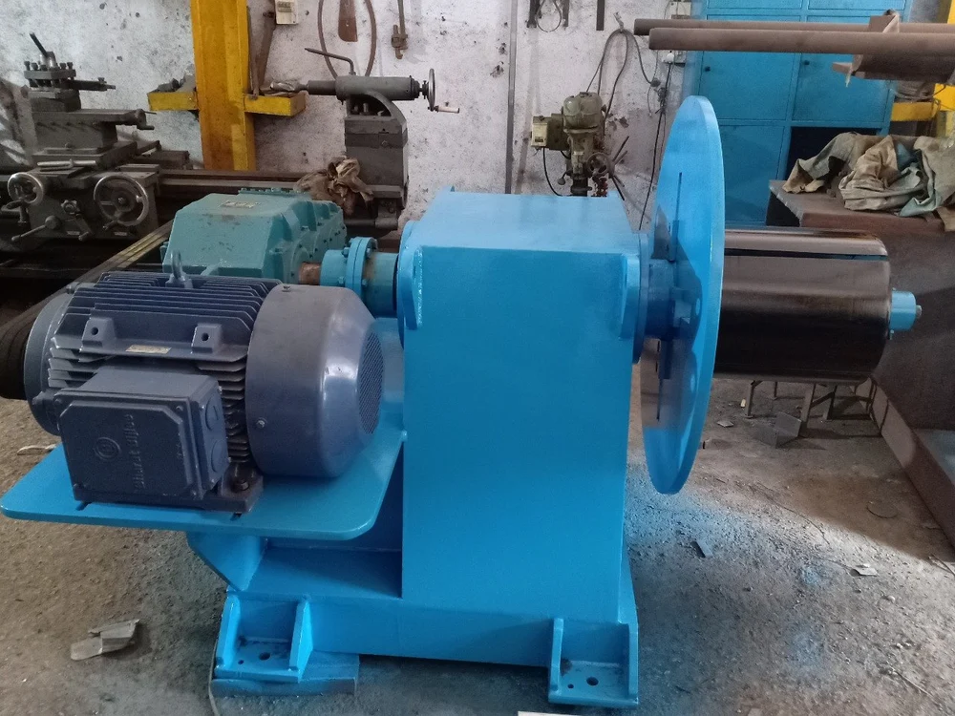

1650 sheet leveler

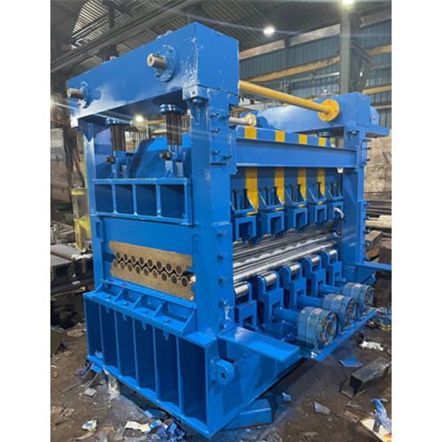

Shearing Machine

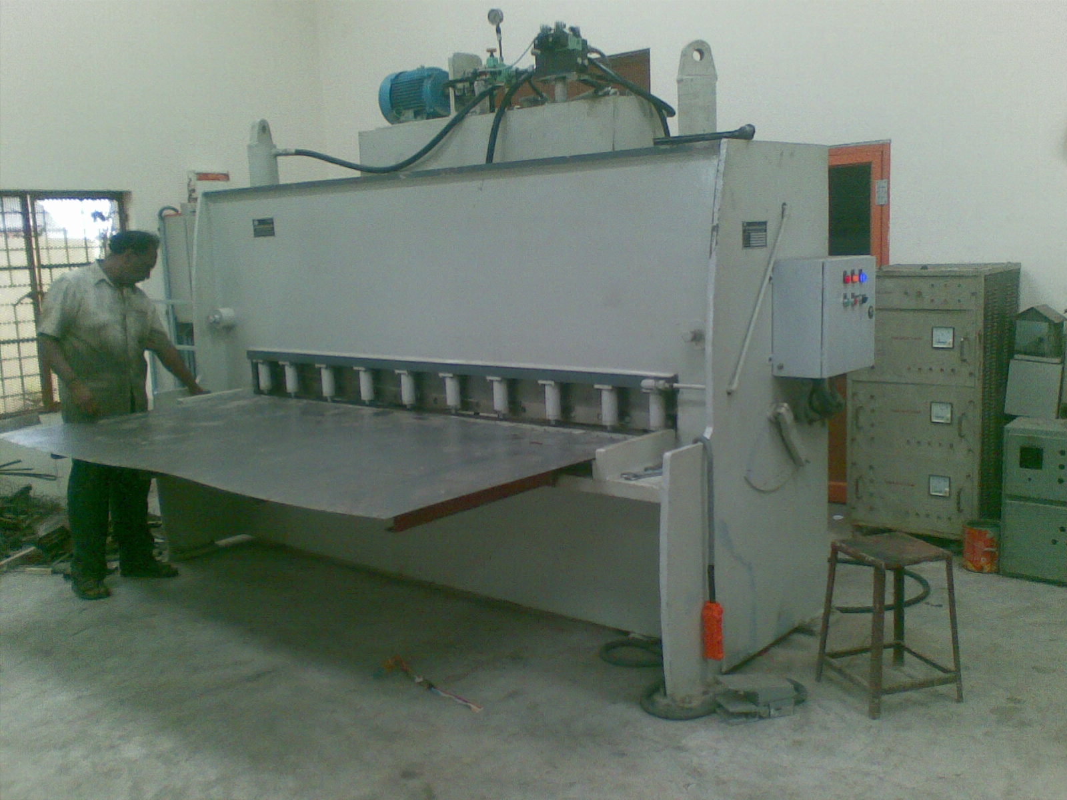

For TECHNO MACHINE TOOLS

(T. SIVARAMAKRISHNA)

